Sitemap: Website Redesign

View or edit this diagram in Whimsical:

<https://whimsical.com/website-redesign-sitemap-9bFMdh9Le6TW1qrtVFqbo2>

[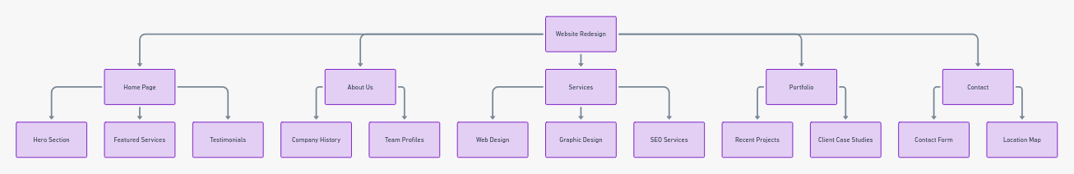](https://whimsical.com/website-redesign-sitemap-9bFMdh9Le6TW1qrtVFqbo2)

Sitemap: Landing Page Content: Exploring St. Helens Sitemap

View or edit this diagram in Whimsical:

<https://whimsical.com/exploring-st-helens-sitemap-9eRnvt13BjfKEyGT2ZbqVJ>

